Final Project Guide #1
APPDEV1 (Introduction to Application Development) December 3, 2025
Technical Document for Project Guide #12
Application Name: Valorant
Developers: Estabillo, Ranulf Jay & Gerardo, Hazel Hyacinth
Introduction
A. Purpose
The purpose of the document is to monitor our progress for our final project and explain what we did on our website.
B. Scope
The goal of our website is to showcase the game Valorant.
Stakeholder/Group Profile
Representative (Group Members) | Ranulf Jay G. Estabillo
Description | He made the website using Angular Application and API.
Type | Valorant Website
Responsibilities | Making the Website

Representative (Group Members) | Hazel Hyacinth D. Gerardo
Description | Make the documentation every meeting.
Type | Valorant Website
Responsibilities | Documenting

Involvement
User Interfaces
UI Name: | Home

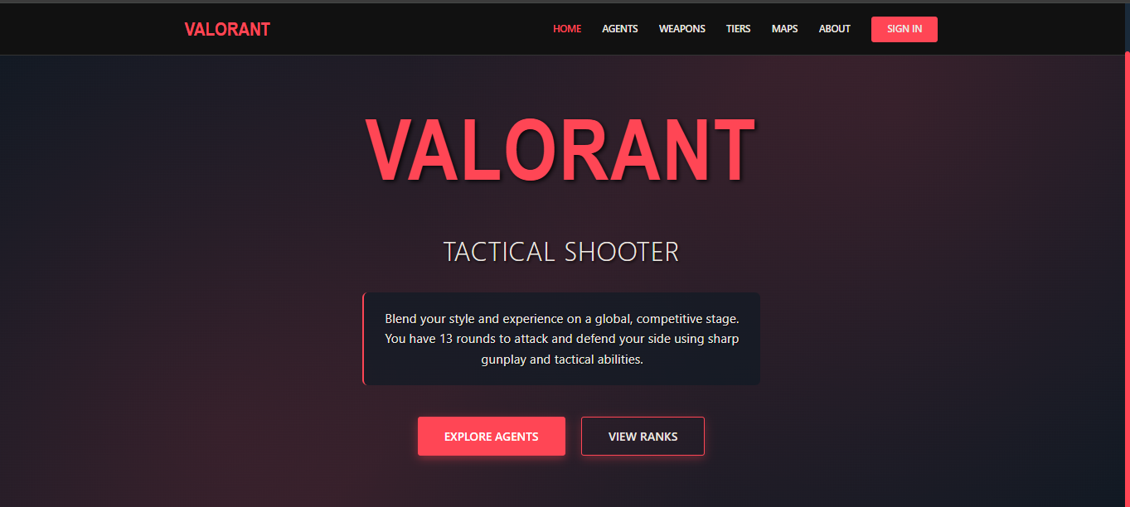
Purpose | Show a brief description about Valorant.
Navigation  and user  interaction | Provides the Agents button and Ranks Button for quick access.

UI Name: | Agents

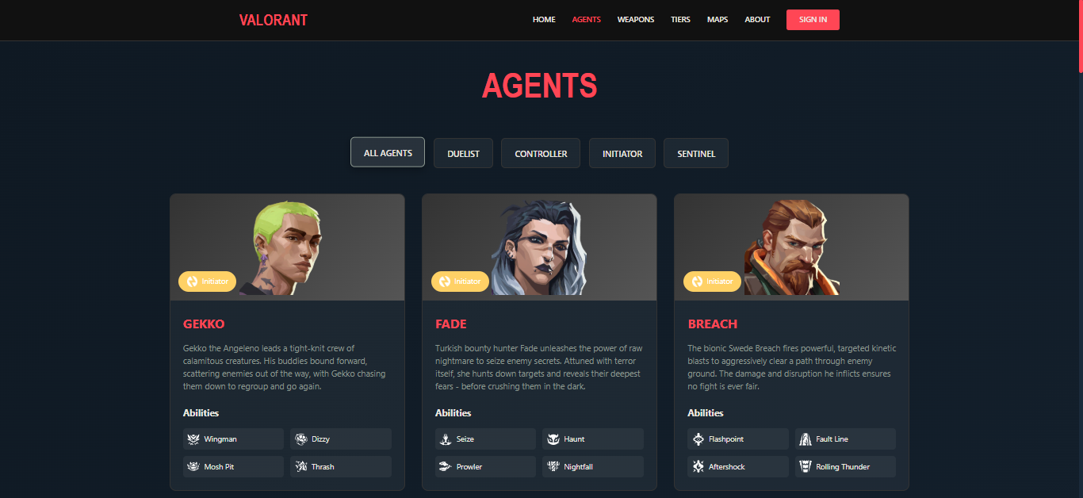
Purpose | Showcase the Agents/characters and their Abilities.
Navigation  and user  interaction | We input buttons that displayed their Roles.

UI Name: | Weapons

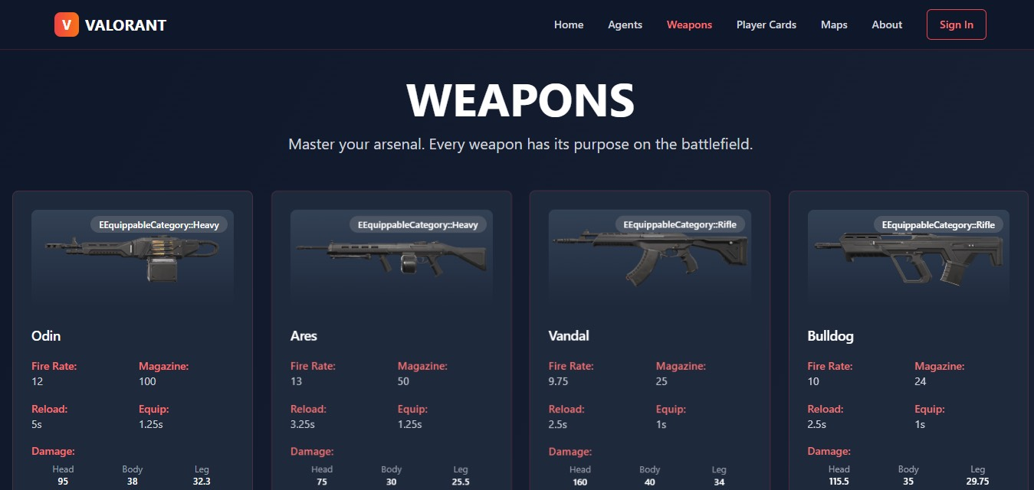
Purpose | This page displays the weapons and its information like the damage, fire rate, how long it takes to reload, magazine, and how long it takes to equip.
Navigation  and user  interaction | The Weapon page shows the information directly, We didn’t put any buttons.

UI Name: | Competitive Tiers

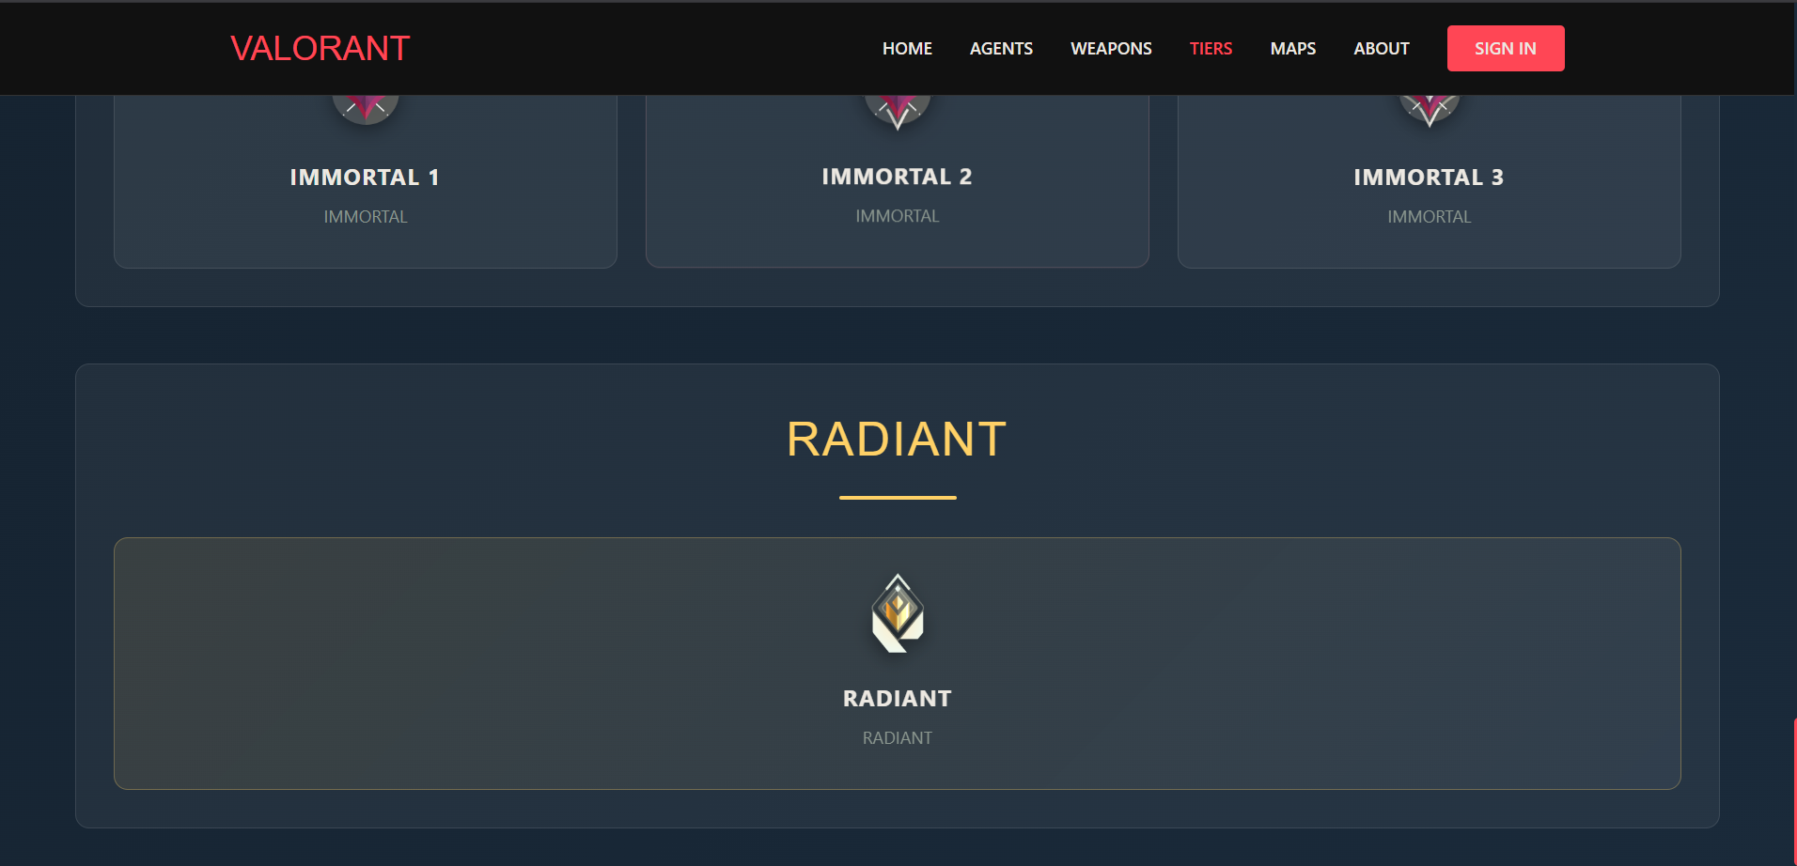
Purpose | This page just shows the different types of Ranks/Tiers in Valorant.
Navigation  and user  interaction | Nothing special in this page, as we just put the information itself.

UI Name: | Maps

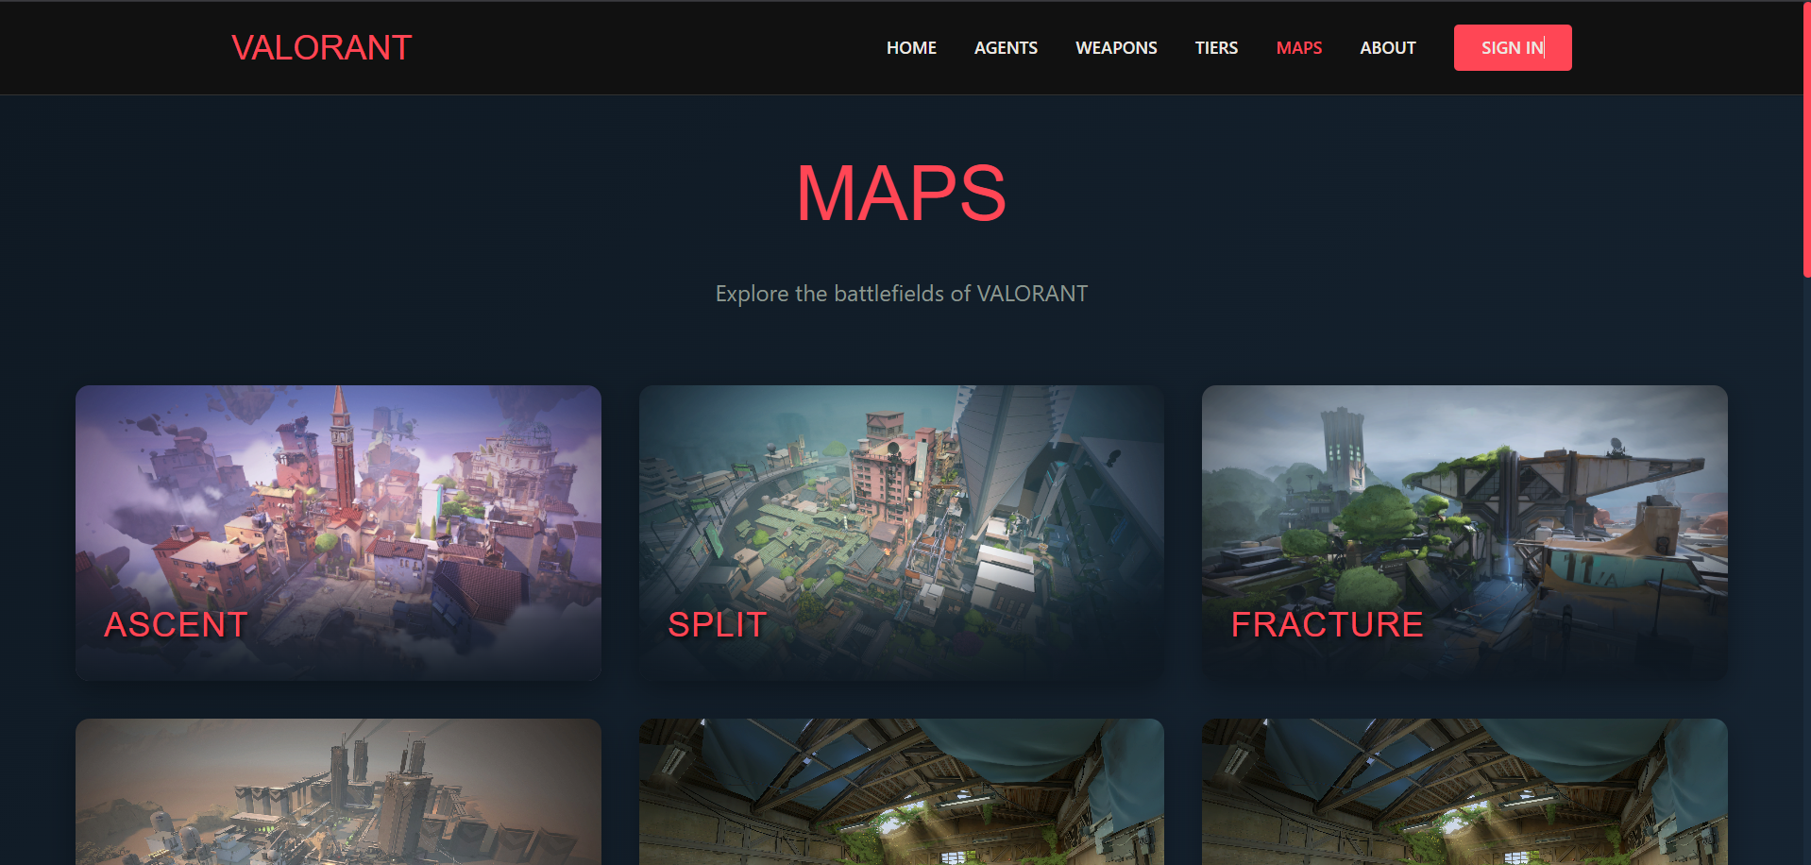
Purpose | To show the different maps in Valorant.
Navigation  and user  interaction | Again nothing special in this page, we just put the image and names of the maps.

UI Name: | About

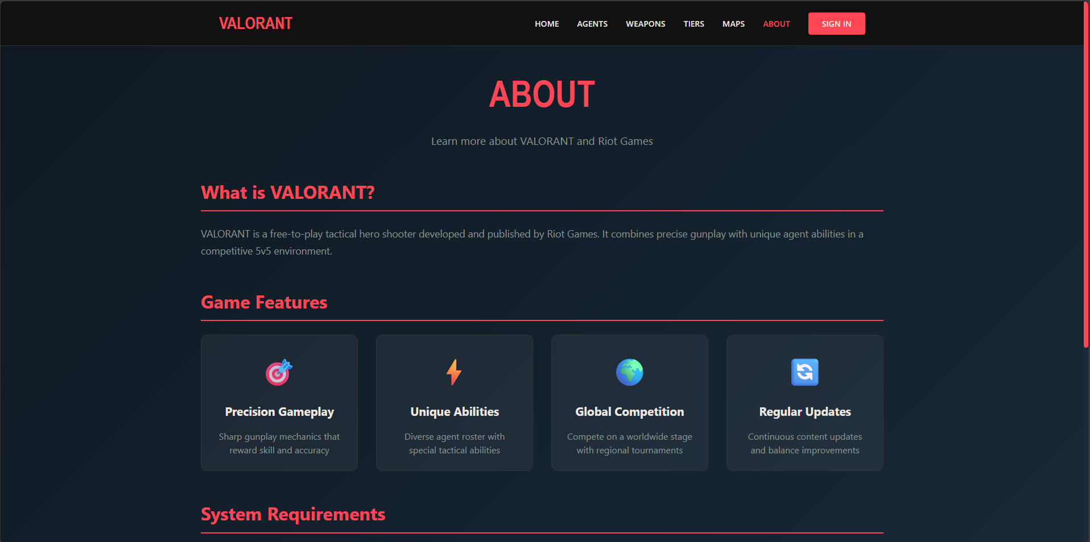
Purpose | Show the more detailed information about the game and the requirements to be able to play the game.
Navigation  and user  interaction | Nothing too special with the page as well, as we just put the description and information in it.

UI Name: | Sign-in

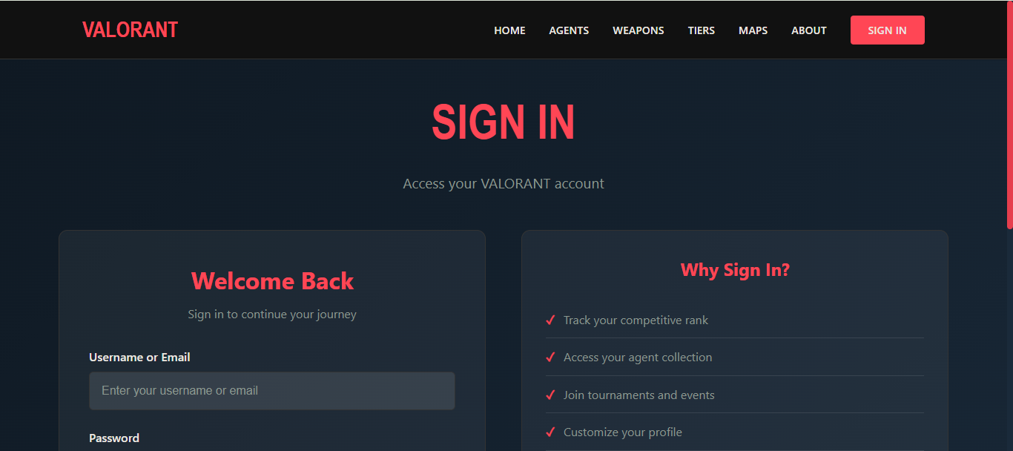
Purpose | To access your Valorant account from our website. Track your ranks, join events, connect with friends and many more.
Navigation  and user  interaction | To input email or username and password on the left side of the screen.

*Hazel wasn't able to put her Curriculum Vitae.